**Press release** *Specialist press*

**Kautex produces 320-liter hydrogen liner in blow molding process**

**Kautex Maschinenbau's blow molding experts have successfully produced a large-volume polyamide liner for hydrogen pressure vessels using extrusion blow molding. The liner is more than two meters long, with a diameter of approximately 500 mm and a volume of 320 liters. This is the first time that a liner for a hydrogen container has been produced in this size by blow molding.**

Hydrogen presents considerable challenges in relation to the liner material’s permeability. Being the smallest molecule in the periodic table, hydrogen can diffuse through virtually every plastic material. Special polyamides (PAs) have the best barrier properties. However, due to their low melt rigidity and complexity, they have previously been difficult to process on this scale by blow molding. Newly developed polyamides and a special extrusion technique have now made this possible.

“Producing a liner of this size from polyamide has been a major challenge. The work we are doing here is truly pioneering”, said Abdellah El Bouchfrati, Head of Kautex’s Composite Business Development, where the new hydrogen liner was developed.

For some time now, Kautex has been putting its efforts into on-going development of composite pressure vessels (CPV) for various applications such as hydrogen, CNG and LPG tanks. Composite tanks consist of a thermoplastic liner, a boss part, to which the valve is connected, and a fiber winding which adds mechanical strength. The internal liner is produced by blow molding.

CPV high-pressure containers for hydrogen are generally designed for an operating pressure of 700 bar and a burst pressure of 1750 bar. The liner is a core component of the container. It is the inner skin of the tank. It absorbs the gas, surrounding the contents and sealing them off from the outside. The liner is subjected to high mechanical stresses and temperature ranges from -60 °C to +120 °C. Now, for the first time, the method developed by Kautex in cooperation with a plastics manufacturer enables hydrogen liners in sizes with industrial applications to be produced by blow molding.

“The liner size we have now achieved is just the start. We are confident that, in future, we will also be able to use this method to produce considerably larger liners for hydrogen pressure vessels”, said Abdellah El Bouchfrati.

The technology developed by Kautex Maschinenbau for producing large-volume liners for hydrogen containers means that a cost-effective solution for transport and infrastructure requirements is now within reach. Experts have long considered sole reliance on battery technologies to provide a solution to tomorrow's mobility problems will not achieve the long-term goal of mobility that is as carbon-neutral as possible.

While fuel cell technology in the passenger car sector does not yet appear to be economically viable, due to production costs and a lack of infrastructure, hydrogen-powered drive and production technologies are already being successfully implemented in other areas. This technology currently appears to be of particular interest for heavy goods transport, local public transport, shipbuilding, and the aircraft industry. In those sectors, the primary demand is for safe, lightweight and leak-proof tank systems. CPVs are not only significantly lighter than steel tanks, but also completely resistant to corrosion.

Hydrogen is also a first-class energy storage medium, especially if it has been produced using renewable energies. Here, too, tank systems that can withstand the associated pressure, and still store the extremely light gas safely, are needed.

Alongside high-tech machines for packaging and automotive products, the company also develops systems for producing thermoplastic pressure vessels. Kautex Maschinenbau’s portfolio ranges from the development and production of prototypes and small series to the construction of complete production systems for manufacturing composite pressure vessels. Working together with its customers and materials manufacturers, Kautex continues to advance developments in CPV technology. The hydrogen liner that has just been unveiled is the latest fruit of this cooperation.

*(4,209 characters, incl. spaces)*

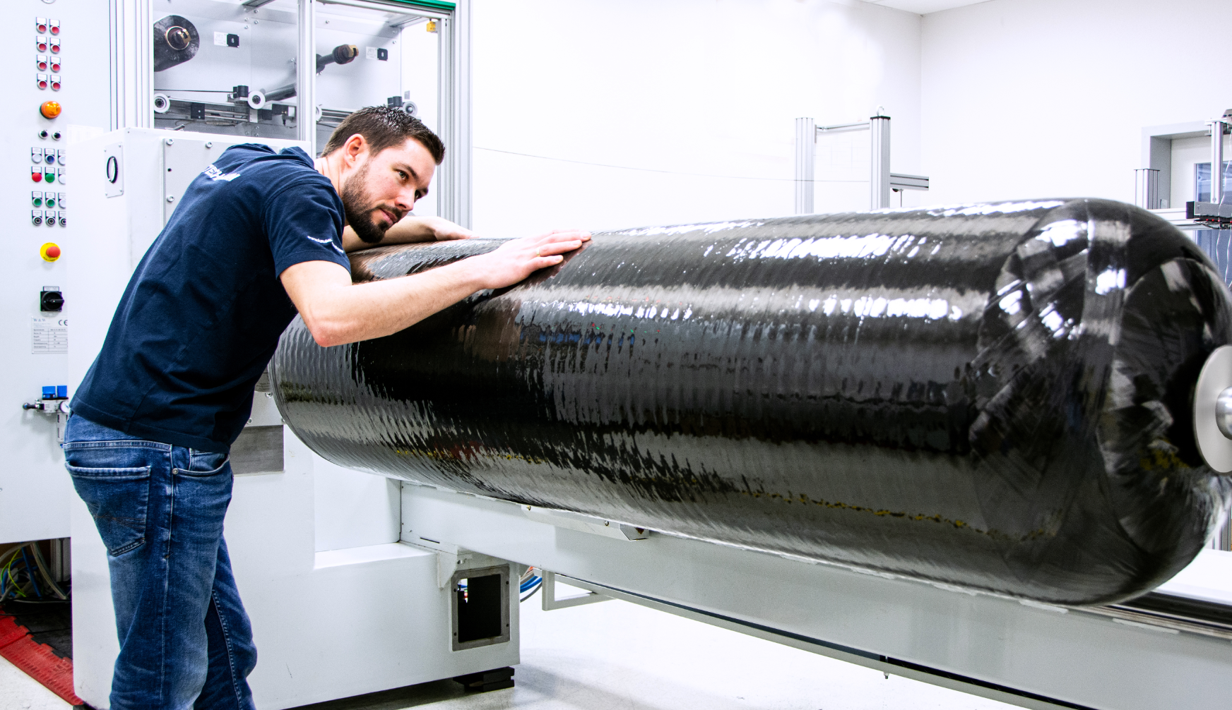  
  
Prototype production in the Kautex Composite Center

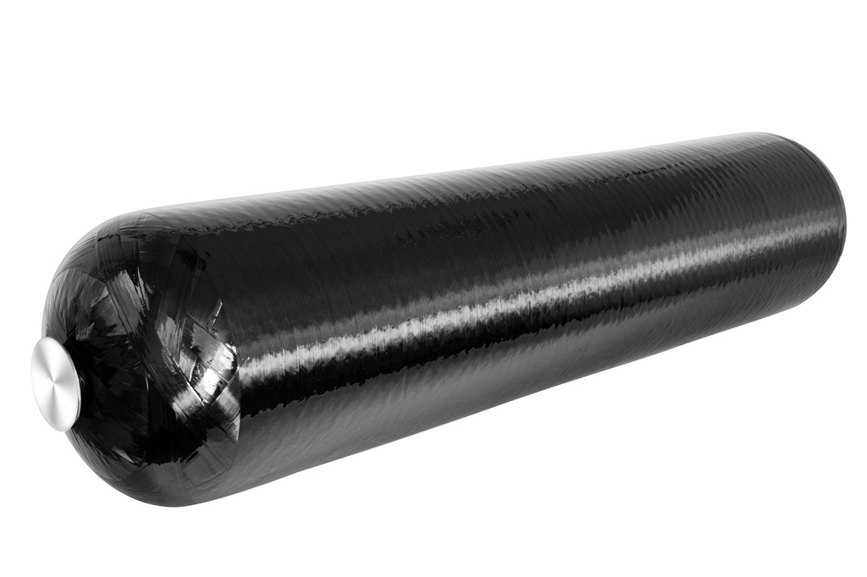

320 l hydrogen pressure vessel

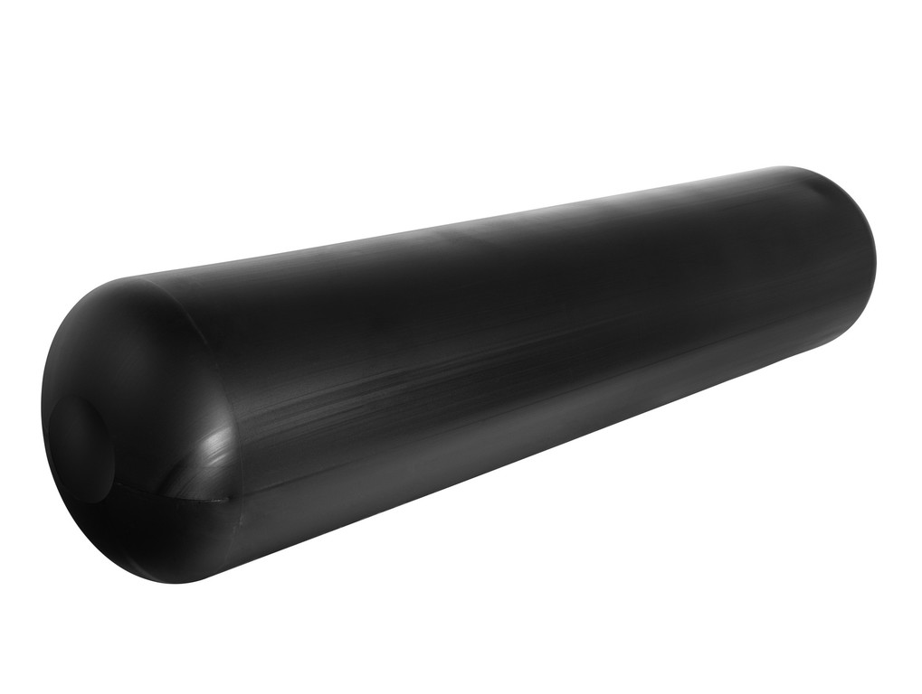

Blow-molded PA liner

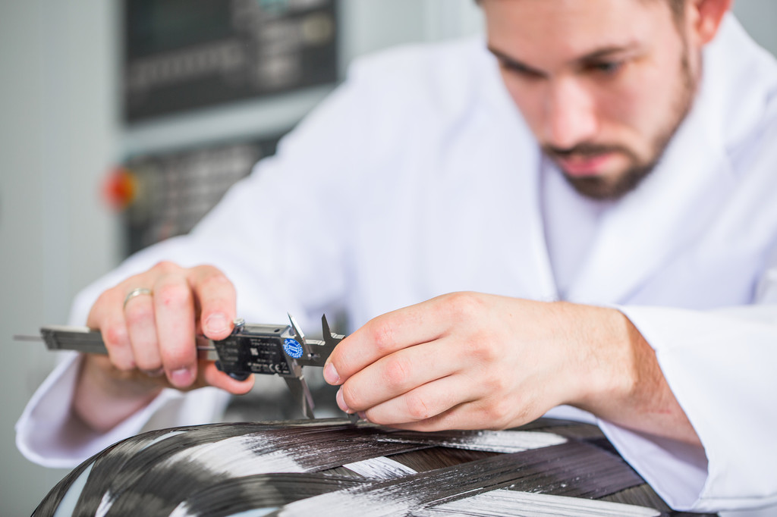  
  
Quality inspection in the Composite Center

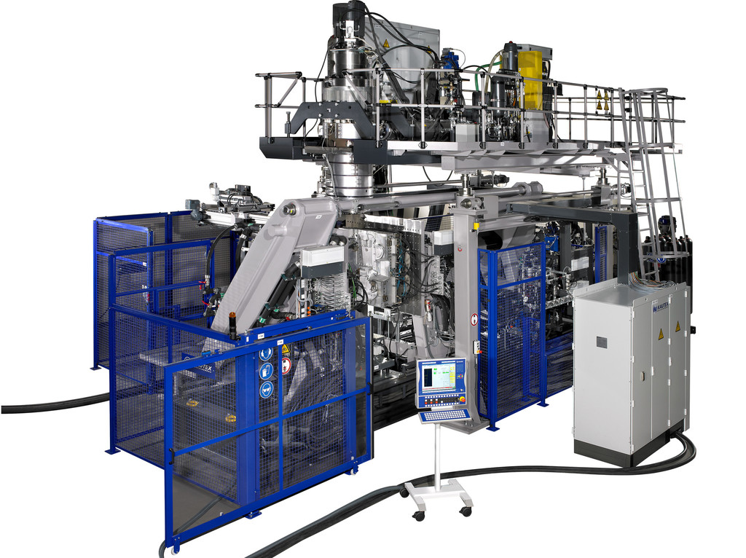

Kautex KBS241 extrusion blow molding machine

**About Kautex Maschinenbau**Eight decades of providing its customers with innovative products and services have turnedKautex Maschinenbau into one of the world's leading companies in extrusion blow molding technology. With customers that include major automobile manufacturers and suppliers, as well as companies working in the packaging industry. All of them have come to rely on the knowledge and experience of a brand that stands for both quality and reliability. In addition to its HQ in Bonn, a Customer Service Center in Berlin and regional offices in the USA, Russia, China, Italy, India, Mexico and Malaysia, Kautex Maschinenbau operates an extensive global network of service and distribution offices. **Contact details**

**Christian Kirchbaumer**  
Head of Marketing Communications

**Kautex Maschinenbau GmbH**  
Kautexstr. 54  
53229 Bonn  
Germany

T +49 228 489370

christian.kirchbaumer@kautex-group.com